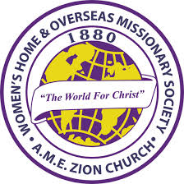
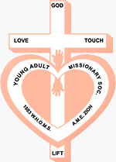
Women’s Home and Overseas Missionary Society
African Methodist Episcopal Zion Church

Y.A.M.S. 40th Anniversary Celebration
“Y.A.M.S. Bling Ball”
Ticket Order Form
Monday, July 24, 9:30 PM
30th WHOMS Quadrennial Convention
Hilton New Orleans Riverside Hotel

Name: ______________________________________________ Date: ____________________

Address: ______________________________________ City: __________________________

State: ___________ Zip Code: ______________ Telephone # _________________________

Email: ____________________________ Episcopal District ___________________________

Conference ________________________ District ____________________________________

Item | Quantity | Price Each | Total
Y.A.M.S. Bling Ball Ticket |  | $30.00

Ticket Ordering Information:
- Tickets available for purchase between January 9th – May 31st
- Make Check Payable To: WHOMS Quadrennial Convention, PO Box 26846, Charlotte, NC 20881; Send Completed Form with Payment
- Cannot accept checks via telephone or website
- Credit Card Payment: Email Completed Form to Rosetta Dunham (rodunham@amezion.org); Call Mrs. Dunham to process credit card payment (704-599-4630, Ext. 2570)
- Tickets will be distributed at the 30th WHOMS Quadrennial Convention
- Tickets will be available for purchase on site, Saturday, July 22, 2023. Payment by check or credit card only.

