Young Adult Missionary Society ~ Historical Review

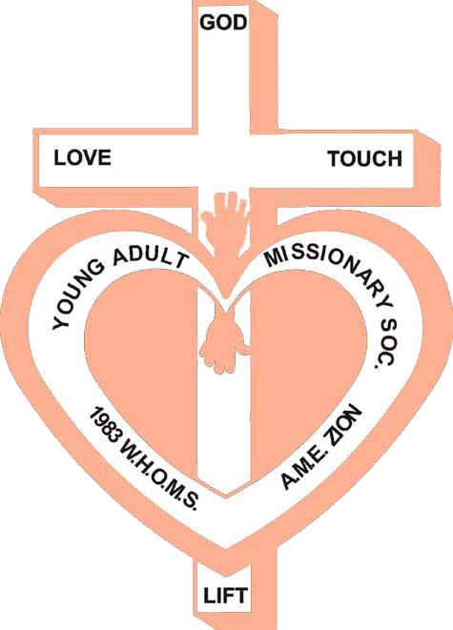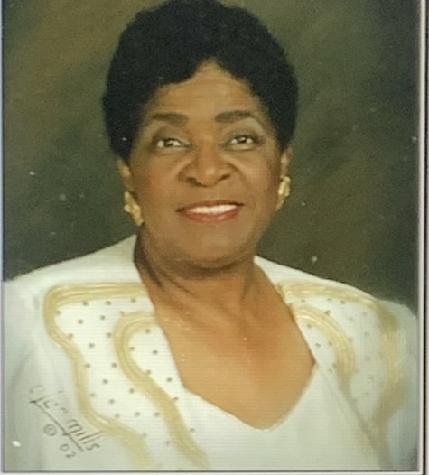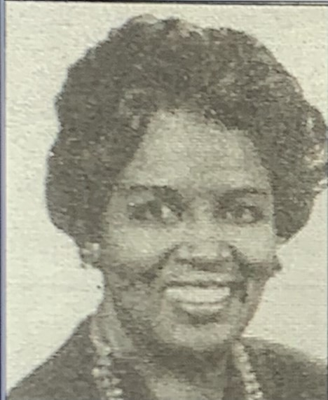

The vision of the Young Adult Missionary Society began in August 1975 when Dr. Willa Mae Rice, then General President of the

WH&OM Society, brought a resolution to the 18th Quadrennial Convention held in Los Angeles, CA to establish a department for

women ages 27-40. The resolution was not adopted, but in 1979 at the 19th Quadrennial Convention held in Miami, FL, the delegates voted to bring the Y.A.M.S. in under the umbrella of the Parent Body.

However, in 1983 at the 20th Quadrennial Convention in New Orleans, LA, the YAM Society was adopted as the sixth Department of the Women’s Home and Overseas Missionary Society. Dr. Adlise I.

Porter, the Second Vice - President, was appointed Coordinator of the Department by the Convention. Through her spiritual gifts, Dr. Porter developed the structure of the Department which included writing

the operational guidelines for the Department’s Thematic Bible

Studies, Social Concerns Projects, motto, colors, and theme song. Prior to the 22nd Quadrennial Convention held in New Orleans, LA, the YA.M.S. Anniversary Day was called “Willa Mae Rice Day”. It was during this Convention that a resolution was adopted to change “Willa Mae Rice Day” to “Founders’ Day” to honor Dr. Rice as Founder and Dr. Porter as the Organizing Coordinator.

In 1991, at the 22nd Quadrennial Convention, Mrs. Joann B. Holmes became the first elected General Coordinator. During the 23rd

Quadrennial meeting, a resolution was adopted to change the ages of

Y.A.M.S from 27-40 to 22-40. To chart the course of the Y.A.M.S.

into the 21st century, Mrs. Sandra B. Crowder was elected the 3rd General Coordinator at the 24th Quadrennial Convention in Dallas, TX. In 2007, at the 26th Quadrennial Convention in Orlando, FL, Mrs. Dawn L. Walker was elected the 4th General Coordinator of the Y.A.M.S. In Orlando, FL, Dr. Joy L. Kennedy, was elected the 5th General Coordinator. During the 29th Quadrennial Convention, a resolution passed changing the title from General Coordinator to Connectional Coordinator. Recently, at the 30th Quadrennial Convention, Ms. Karlease M. Smalls was elected as the 6th Connectional Coordinator of Y.A.M.S., in New Orleans, LA.

**Y.A.M.S. MOTTO**

“With hearts and hands,

We reach up to God for strength and direction.

We reach out to love and touch others.

We reach down to lift fallen humanity.”

*Young Adult Missionary Society*

*40th Anniversary 1983-2023*

*Founders’ Day Observance*

Dr. Willa Mae Rice-Founder Dr. Adlise Ivey Porter– Organizing Coordinator

November 12, 2023

2023-2027 Quadrennial Theme: Reaching the Masses in an Ever-Changing World:

The Journey Continues!

~ Self - Care & Wellness ~

Women’s Home and Overseas Missionary Society The African Methodist Episcopal Zion Church

Ms. Karlease Smalls

Connectional Coordinator of the Y.A.M.S.

Mrs. Sandra Crowder

International President of the WH&OMS

Processional

Order of Worship

The Gloria Patri

The Affirmation of Faith

Call to Worship (Psalm 103: 1-4)

Let all that I am praise the Lord; with my whole heart, I will praise his holy name. Let all that I am praise the Lord; may I never forget the good things He

does for me. He forgives all my sins and heals all my diseases. He redeems me from death and crowns me with love and tender mercies.

Invocation

Hymn of Praise “*Our Promise, Praise and Petition*” (BH #671) Responsive Reading (Isaiah 38:16-20 NLT)

**Leader**: Lord, your discipline is good, for it leads to life and health. You restore my health and allow me to live!

**People:** Yes, this anguish was good for me, for you have rescued me from death and forgiven all my sins.

**Leader:** For the dead cannot praise you; they cannot raise their voices in praise. Those who go down to the grave can no longer hope in your

faithfulness.

**People:** Only the living can praise you as I do today. Each generation tells of your faithfulness to the next.

**All**: Think of it– the Lord is ready to heal me! I will sing his praises with instruments every day of my life in the temple of the Lord.

The Scripture Lesson *Ephesians 4:17-32 (NLT)*

Prayer

Choral Selection Option: William Murphy “You Are My Strength”

Founders’ Day Tributes to Dr. Willa Mae Rice and Dr. Adlise Ivey Porter

The Offering/The Offertory

Introduction of the Founders’ Day Messenger

Sermonic Selection Option: Richard Smallwood “Total Praise”

Founders’ Day Message:

Theme: “Self - Care & Wellness”

Invitational Hymn “Great is Thy Faithfulness” (BH #80) Invitation to Christian Discipleship

Remarks

Missionary Benediction

“God be merciful unto us, and bless us, and cause His face to shine upon us and give us peace.” Amen.

Please send funds for Founders’ Day to the Executive Director’s Office.