Young Adult Missionary Society ~ Historical Review

The vision of the Young Adult Missionary Society began in August 1975 when Dr. Willa Mae Rice, then General President of the WH&OM Society, brought a resolution to the 18th Quadrennial Convention held in Los Angeles, CA to establish a department for women ages 27-40. The resolution was not adopted, but in 1979 at the 19th Quadrennial Convention held in Miami, FL, the delegates voted to bring the Y.A.M.S. in under the umbrella of the Parent Body.

However, in 1983 at the 20th Quadrennial Convention in New Orleans, LA, the YAM Society was adopted as the sixth Department of the Women’s Home and Overseas Missionary Society. Dr. Adlise I. Porter, the Second Vice - President, was appointed Coordinator of the Department by the Convention. Through her spiritual gifts, Dr. Porter developed the structure of the Department which included writing the operational guidelines for the Department’s Thematic Bible Studies, Social Concerns Projects, motto, colors, and theme song. Prior to the 22nd Quadrennial Convention held in New Orleans, LA, the YA.M.S. Anniversary Day was called “Willa Mae Rice Day”. It was during this Convention that a resolution was adopted to change “Willa Mae Rice Day” to “Founders’ Day” to honor Dr. Rice as Founder and Dr. Porter as the Organizing Coordinator.

In 1991, at the 22nd Quadrennial Convention, Mrs. Joann B. Holmes became the first elected General Coordinator. During the 23rd Quadrennial meeting, a resolution was adopted to change the ages of Y.A.M.S from 27-40 to 22-40. To chart the course of the Y.A.M.S. into the 21st century, Mrs. Sandra B. Crowder was elected the 3rd General Coordinator at the 24th Quadrennial Convention in Dallas, TX. In 2007, at the 26th Quadrennial Convention in Orlando, FL, Mrs. Dawn L. Walker was elected the 4th General Coordinator of the Y.A.M.S. In Orlando, FL, Dr. Joy L. Kennedy, was elected the 5th General Coordinator. During the 29th Quadrennial Convention, a resolution passed changing the title from General Coordinator to Connectional Coordinator. Recently, at the 30th Quadrennial Convention, Ms. Karlease M. Smalls was elected as the 6th Connectional Coordinator of Y.A.M.S., in New Orleans, LA.

**Y.A.M.S. MOTTO**

“With hearts and hands,

We reach up to God for strength and direction.

We reach out to love and touch others.

We reach down to lift fallen humanity.”

*Young Adult Missionary Society 40th Anniversary*

*1983-2023*

*Founders’ Day Observance*

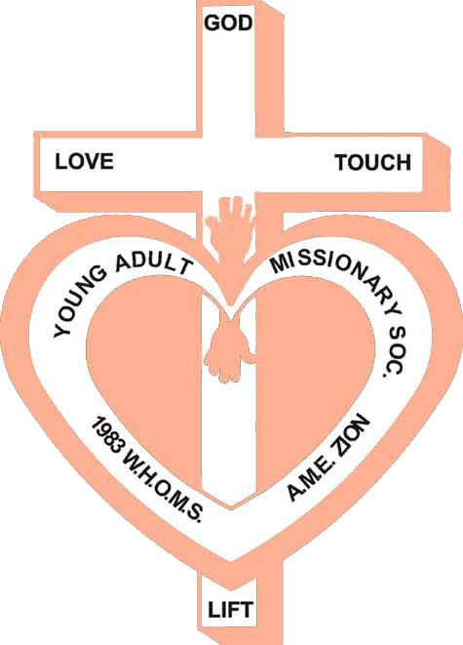

2023-2027 Quadrennial Theme: Reaching the Masses in an Ever-Changing World:

The Journey Continues!

~ Self - Care & Wellness ~

Women’s Home and Overseas Missionary Society The African Methodist Episcopal Zion Church

Ms. Karlease Smalls

Connectional Coordinator of the Y.A.M.S. Mrs. Sandra Crowder

International President of the WH&OMS

PRAYER

PROGRAM

Puzzle to Relieve Stress

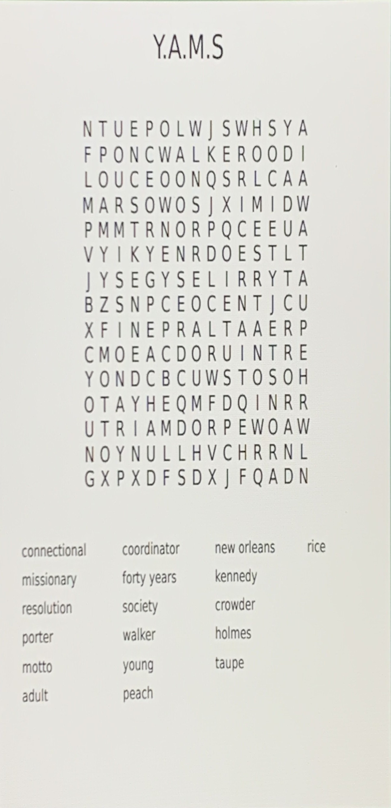

SCRIPTURE:*EPHESIANS 4:17-32 (NLT)*

MEDITATION EXERCISE: SIT STRAIGHT IN BALANCED POSITION WITH CLOSED EYES; FOCUS ON SLOW ABDOMINAL BREATHING FOR 3 MINUTES; CLEAR YOUR MIND AND FOCUS ONLY ON YOUR BREATHING.

(FOR ADDED BENEFIT, ADD WHITE NOISE MACHINE OR OCEAN SOUNDS IN BACKGROUND.)

ACTIVITY #1: BREAK INTO GROUPS AND DISCUSS REFLECTIVE QUESTIONS.

ACTIVITY #2: CREATE AFFIRMATION JAR: TAKING PIECES OF PAPER, WRITE DOWN SEVERAL AFFIRMA- TIONS AND PLACE THEM IN THE MASON JAR.

CLOSING REFLECTIONS & PRAYER

REMEMBER TO REST, RELAX, REPLENISH,

AND RELEASE

SELF-CARE & WELLNESS TIPS

* **S**ET A SCHEDULE.
* **E**XPRESS BOUNDARIES.
* **L**EAVE ROOM FOR GOD TO INTERVENE.
* **F**ILL MIND WITH POSITIVITY.
* **C**ONSIDER A RELAXATION TECHNIQUE.
* **A**PPRECIATE ALONE TIME.
* **R**EGULATE SLEEP CYCLE WITH HEALTHY SLEEP PATTERNS.
* **E**NGAGE IN MEDITATION.
* **W**ATCH STRESS LEVELS.
* **E**XERCISE.
* **L**IVE EACH MOMENT TO THE FULLEST.
* **L**OVE AND SHOW GRATITUDE TO OTHERS.
* **N**EVER APOLOGIZE FOR SAYING NO.
* **E**AT HEALTHY.
* **S**TAY HYDRATED.
* **S**PLURGE ON YOURSELF.

Reflective Questions

* 1. As missionaries, in what ways can we practice self-care?
  2. Describe your personal support system in 3 ways.
  3. As a Young Adult, is there guilt associated with self-care? Yes or no. Explain.
  4. Is there conflict with self-care and wellness as missionaries?
  5. Do our daily lives and church schedules promote wellness? If not, in what ways can we make adjustments to promote wellness?
  6. How does Self-Care and Wellness tie into

our motto?

Examples of Wellness Activities:

Meditate, Visit a Paint Class, Get a Massage, Write in a Journal, Hiking, Gardening, Plan a Vacation/Staycation, and Jogging