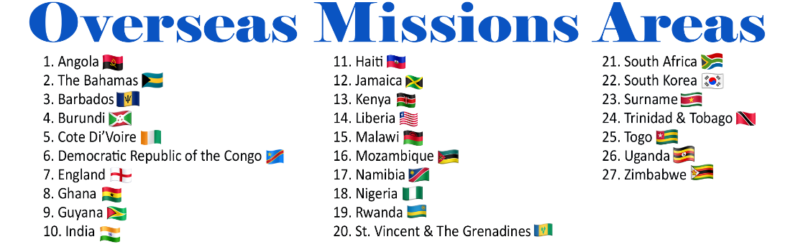

**Leader:** There are other THE AFFIRMATION OF FAITH

*GLORIA PATRI*

THE MUSIC MINISTRY

THE SCRIPTURE LESSON Matthew 28:16-20 & John 10:16 **A Missionary**

THE PASTORAL PRAYER/RESPONSE

**THE MISSIONS APPEAL** *(See back of this bulletin)* **A Missionary**

***THE MISSIONS OFFERING***

THE ANNOUNCEMENTS/GREETINGS

THE PRESENTATION OF THE PREACHER/SPEAKER **A Missionary**

THE HYMN/SONG OF PREPARATION

**THE MISSIONS MESSAGE**

TEXT: ________________________________________

SUBJECT: _____________________________________

THE INVITATION TO CHRISTIAN DISCIPLESHIP

GOD’S TITHES AND OUR OFFERINGS/ *OFFERTORY*

THE RECESSIONAL

THE MISSIONARY BENEDICTION: *“God be merciful unto us and bless us and cause His face to shine upon us and give us peace.” Amen.* (Adapted from Psalm 67:1)

**ORDER OF WORSHIP**

**Theme:** *Expanding The Flock & Sharing Our Faith* Matthew 28:16-20 & John 10:16

THE ORGAN PRELUDE

THE PROCESSIONAL HYMN *“God of Grace and God of Glory”* AMEZH #227

THE CALL TO WORSHIP **Worship Leader**

Jesus said to them, *“I am the door of the sheep,”* let us enter through Him to worship, be saved, edified, and fortified to go out into the pasture.

THE INVOCATION *Prayer of Saint Francis* **A Missionary**

Lord, make me an instrument of Your peace, where there is hatred, let me sow love, where there is injury, pardon, where there is doubt, faith, where there is despair, hope, where there is darkness, light, and where there is sadness, joy. O Divine Master, grant that I may not so much seek to be consoled as to console, to be understood as to understand, to be loved as to love. For it is in giving that we receive, it is in pardoning that we are pardoned, and it is in dying that we are born to eternal life. *Amen.*

THE HYMN OF PRAISE *“Savior Like A Shepherd Lead Us”*  AMEZH #278

THE RESPONSIVE READING **A Missionary**  *adapted by Rev. Nicole Jean-Simon: Taken from John 10:11-18 (Good News Translation)*

**Leader:** Jesus is the Good Shepherd, Who is willing to die for the sheep.

**People:** We are the sheep, the beneficiaries of the death and resurrection of Jesus.

**Leader:** When the hired ones, who are not shepherds and do not own the sheep, see a wolf coming, they leave the sheep and run away. So, the wolf snatches the sheep and scatters the flock.

**People:** We are the flock that the enemy intended to scatter, but what the enemy meant for evil, God intended for good. What was scattered has now expanded.

**Leader:** The hired ones run away because they are only hired and do not care about the sheep. But Jesus is the Good Shepherd. As the Father knows His Son and the Son knows the Father, in the same way Jesus knows His sheep and they know Jesus.

**People:** We are the sheep who know Jesus. Our faith rest upon Him and we will share our faith with others because the Gospel message is too good to keep to ourselves. 

**Leader:** There are other sheep which belong to Jesus that are not yet in the sheep pen. They will be drawn to Jesus. They will hear His voice, and we will become one flock with one Shepherd.

**People:** Use us Lord to expand the flock and share the faith.

**Leader:** The flock includes our families, co-workers, friends, and strangers. Give us boldness to share our faith with love and compassion.

**TOGETHER:** **All:** By doing this we are expanding the flock and sharing our faith. This is the mandate we must follow, and we do it with gladness.



GLOBAL MISSIONS SUNDAY 2022

**Theme:** *Expanding The Flock & Sharing Our Faith*

*“… Go therefore and make disciples of all nations, baptizing them in the name of the Father and of the Son and of the Holy Spirit,**teaching them to observe all that I have commanded you. And behold, I am with you always, to the end of the age.”*

Matthew 28:16-20 (ESV)

***(***Suggested observance for ***Global Missions Sunday*** is September 25, 2022 or any date the local church designates.)

MISSIONS’ OFFERING APPEAL

**Expanding The Flock & Sharing Our Faith**

The world, as it is today, with its hatred, bigotry, selfishness, and distrust seems intimidating and unrelenting. Many are doubtful and dare I even say fearful of going into all the world to make disciples. They trust God and Jesus’ authority but may doubt their own ability to be effective or safe. Christians/Missionaries should not allow their insecurities to deter them from the authority given to them by Jesus and the assurances given by both God and Christ Jesus. God said to *“be strong and courageous. Do not fear or be in dread of them, for it is the LORD your God who goes with you. He will not leave you or forsake you.”* Deut 31:6 (ESV) Then Jesus says in Matthew 28:19-20 to Go and expand the flock by making disciples and He will always be with you.

Some may be physically unable to go because of disabilities or circumstances but they can still go. Going also requires sending of love through financial sacrifices and materials to support those that are hands-on, actually, **Expanding the Flock and Sharing Our Faith** outside of the comfort of the established Church building. Giving is physical, spiritual, and financial. When we are willing to give and share with others, then the flock starts to expand through our love.

Yes, this pandemic has shown a light on the plight of the spiritually hungry worldwide. This has motivated many to “GO” virtually and physically in innovative ways to feed and gather the sheep. If at all possible, then we should be willing to help. Help is not about the quantity of what we share. Help is the hands you give with a heart of love for God and humankind that none should be lost.

So Zion, we are challenged to look within and ask ourselves, are we willing to help **Expand the Flock by Sharing Our Faith** as we stand on the promises that little becomes much when placed in the Master’s hand! As you ponder your response, remember**,** Luke 6:38 (ESV) *“Give, and it will be given to you. Good measure, pressed down, shaken together, running over, will be put into your lap. For with the measure, you use it will be measured back to you.”*

Zion, let us get out of our comfort zone and be willing to GO and to help, as we work to **Expand the Flock and Share Our Faith** throughout the world.

**NOTE:**

Please mail all donations to:

The Department of Global Missions

P.O. Box 26770 Charlotte, NC 28269