**“Throw Out the Lifeline”**

1. Throw out the lifeline across the dark wave! There is a brother whom someone should save; Somebody’s brother! O who then will dare to throw out the lifeline, his peril to share?
2. Throw out the lifeline with hand quick and strong: Why do you tarry, why linger so long? See! He is sinking! Oh, hasten today, and out with the lifeboat! Away, then, away!
3. Throw out the lifeline to danger fraught men, sinking in anguish where you’ve never been, winds of temptation and billows of woe will soon hurl them out where the dark waters flow.
4. Soon will the season of rescue be o’er, soon will they drift to eternity’s shore; haste then, my brother, no time for delay, but throw out the lifeline and save them today.

CHORUS:

Throw out the lifeline! Throw out the lifeline! Someone is drifting away.

Throw out the lifeline! Throw out the lifeline! Someone is sinking today.

+ + + + +

The Life Members Council is designated as the Educational Arm of the Women’s Home and Overseas Missionary Society. Membership in the Council enables the Society to support the ministries on the Tree of Hope. Because of your investment and continued support, financial assistance is given to Hood Theological Seminary, Livingstone College, Clinton College, Lomax-Hannon Junior College, A.M.E. Zion University, and Hood Speaks Theological Seminary. Funds are also used to provide grants and scholarships to students attending these institutions, to pay stipends for field workers, to fund Missionary Education Leadership Training in America and overseas, and to support the general operation of the Society.

We thank you for your support.

Program Prepared By: Mrs. Vanessa E. Clayton

*Connectional Chairman, Life Members Council 2019 - 2023*

Mrs. Sandra B. Crowder, International President

*Women’s Home and Overseas Missionary Society*

*The African Methodist Episcopal Zion Church*

**Please send your Anna L. Anderson contributions to your District President for remittance to the Executive Director, Mrs. Rosetta Dunham.**

Women’s Home and Overseas Missionary Society

*The African Methodist Episcopal Zion Church*

In Memory of

Anna Lucille Green Anderson

**Life Members Council**

October 2022

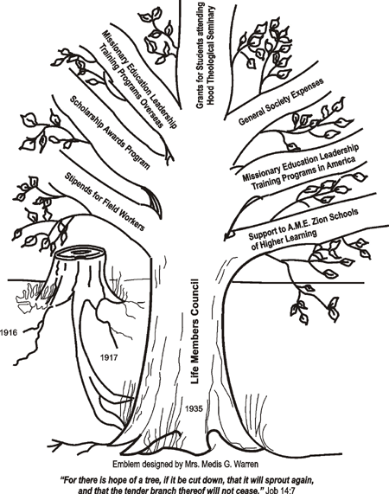

**Quadrennial Theme: 2019 ~ 2023**

**THE GREAT COMMISSION: #MissionsMatter**

**Globally Committed to** *SOCIAL JUSTICE*

*ENVIRONMENTAL STEWARDSHIP,*

*TRANSFORMATIVE SERVICE,*

*AND* ***AGAPE LOVE***

 Women’s Home and Overseas Missionary Society

**Anna L. Anderson Day Observance**

**The Processional or Praise & Worship**

**The Call to Worship**

It is good to praise the**LORD.** and make music to your name, O Most High, to proclaim your**love** in the morning. and your faithfulness at night. (Adapted from Psalm 103:1-5)

**The Invocation** *(Seated and heads bowed)*

God of love—Father, Son, and Holy Spirit: You loved us before we ever knew You. Give us such a deep love for You, that we can see the world as You see it,

feel the compassion You feel and be a people whose lives facilitate Your love to others. So, open our eyes that we might see what the Good Samaritan saw.

Grant us the insight to see the need in others, the wisdom to know what to do, and the will to do it. In Jesus loving name. Amen. (from thepastorsworkshop.com [*Richard Herman*](https://www.richardhherman.com/))

**The Hymn of Praise**  #429 “Love Lifted Me”

**The Litany**.

**Leader:** We are to have the same type of love that Jesus Christ had for us, which

is agape love.

People: **We will never say, “What’s in it for me?”**

**Leader:** Agape love is not friend, sexual, or brotherly love. Agape love is

sacrificial love.

People: **Agape love shows action**.

**Leader:** Let us humble ourselves before the Lord.

People: **We will put others before ourselves.**

**Leader:** God’s agape love is in all believers.

**All:** **We will do all things with the love of God, expecting nothing in**

**return!**

**The Scripture** 1 John 4:7-16

**The Prayer**

**The Prayer Hymn** #266 “Oh, How I Love Jesus”

**The Response to Agape Love**

**As we close out this quadrennial, let us reflect on all the components we have studied: social justice, environmental stewardship, and transformative service. Agape love encompasses our entire being as Christians and missionaries.**

**Regarding social justice, there are several examples of hate and injustice thrown at us every day. Let us resolve to do something or speak out in love to counteract the negative effects in our communities. As Michelle Obama said, “When they go low, we go high.” Let us speak love to power and follow up with action.**

**Always remember that God charged us to take care of His earth. He made it beautiful, and we are to lovingly protect it. As the educational arm of missions, we are to constantly educate our children and our communities about how to sustain, protect and beautify our neighborhoods and open spaces.**

**Finally, transformative service is love in action. Let us continue greater acts of love – doing for others in all circumstances. Agape love goes beyond loving those who are easy to love. We must make the choice to love no matter what, in bigger and more effective ways.**

**Therefore, let Christ shine through in all we do and His agape love will make this world a better place.**

**The Introduction of the Messenger**

**The Choral Selection**

**The Message/Meditation**

**The Invitation to Christian Discipleship**

**The Invitational Selection**

**A Memorial Moment for Anna L. Anderson andDeceased Life Members**

**The Rededication Call to all Life Members** *(In Unison around the Altar)*

We, the members of the Life Members Council, come with love in our hearts and minds. Continue to strengthen us, Lord, filling us with Your precious Holy Spirit. Only then will we be able to build bridges, knock down barriers; and proclaim peace and harmony with our fellow citizens from all segments of this global society. As the educational arm of missions, strengthen the Life Members Council. Commit us anew to fulfilling our Motto: “Each One Make One”. We thank You for Your wisdom, Your strength, Your power and Your agape love. In Jesus’ Name we claim victory! Amen

**The Offering and Offertory**

**The Stoling Ceremony** ***(Optional)***

**The Theme Song** #677 “Throw Out the Lifeline”

**The Life Members Appeal for New Memberships**

**The Special Awards/Presentations/Recognitions** ***(Optional)***

**The Remarks**

**The Missionary Benediction** *(Congregation Seated)*

*“God be merciful unto us and bless us; and cause His face to shine upon us and give us peace. Amen*