Women’s Home and Overseas
Missionary Society
The African Methodist Episcopal Zion Church

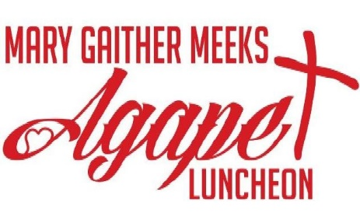

Transforming Lives Through Love

February 2022
Second Mile Anniversary

Quadrennial Theme:
The Great Commission# Mission Matter
Globally Committed to: Transformative Service

Ms. Angela Davis-Baxter, Connectional First Vice President
Mrs. Sandra B. Crowder, International President

Mary Gaither Meeks Agape Luncheon

Opening Selection: “I Love to Praise Him”
Composed by: Jessy Dixon

Scripture: Psalm 51:10

Prayer:

Litany of Love:

Leader: May Love shatter us and rebuild us anew.

People: May Love encompass us and protect us.
Leader: May Love reform us from violence and power-seeking.
People: May Love make us compassionate.

All: May Love teach us to walk in the new way, the beautiful way.

(http://www.franpratt.com/litanies/2016/3/22/3sxzxn1pnu6mtfpdfzj56b2zwoxbtb)

History of the Agape Luncheon
Introduction of Presentation/Speaker:
Selection:

Presentation/ Speaker:
Agape Offering Appeal:

Sharing of Meal:
Remarks:

Missionary Benediction:
Please send financial support to the district president for remittance to the Executive Director, Mrs. Rosetta Dunham.
History of the Agape Luncheon
The Agape Luncheon serves as a permanent means of raising funds for the Second Mile Project, Mrs. Mary Gaither Meeks, First Vice President (1971-1979), in 1973, during her first tenure in office, presented a resolution to the Executive Board asking approval of the idea of the Agape Luncheon. The resolution was adopted. In her first report to the Quadrennial Convention, May 1975 in Los Angeles, California.
In 1979, delegates to the 19th Quadrennial Convention voted to name the Agape Luncheon the Mary Gaither Meeks Agape Luncheon in memory of the First Vice President who had proposed the idea and had been a strong advocate of sacrificial sharing.

Contributions from Second Mile activities provide funds to be given based on needs – one year to Home Mission projects and the following year to Overseas Mission projects.

I Love to praise Him
I Love to Praise His name
I love to praise Him
I love to praise His name
I love to praise His holy name
He's my rock
My Rock, My Sword and Shield
He's my will in the middle of the will
I know he'll never let me down
He's just the jewel that I have found
Hallelujah Hallelujah I love to praise His name
Hallelujah Hallelujah I love to praise His name
Hallelujah Hallelujah I love to praise His name
I love to praise His holy name

