**Order of Worship**

**The Call to Worship**

*Leader: Your steadfast love, Lord, never ceases,*

***People:*** *Your mercies never come to an end;*

*Leader: They are new every morning; so let us proclaim -*

***All:*** *Great is your faithfulness. Great is Your love. Great is Your mercy. And greatly is Your name to be praised!*

**The Invocation**

**The Hymn of Praise** *“Our Promise, Praise, and Petition” #671*

**The Responsive Reading (2 Corinthians 4: 4-7)**

*Leader:* The god of this age has blinded the minds of unbelievers,  
**People:** so that they cannot see the light of the gospel that displays the glory of Christ, who is the image of God.

*Leader:* For what we preach is not ourselves, but Jesus Christ as Lord.  
**People:** and ourselves as your servants for Jesus’ sake.

*Leader:* For God, who said, “Let light shine out of darkness,” made his light shine in our hearts to give us the light of the knowledge of God’s glory displayed in the face of Christ.   
**ALL:** But we have this treasure in jars of clay to show that this all-surpassing power is from God and not from us. Amen.

**The Gloria Patri**

**The Affirmation of Faith** *“The Apostles’ Creed”*

**The Scripture Lesson *Matthew 5:14-16***

**The Prayer**

**The Choral Selection(s)**

**The Founders Day Tributes to Dr. Willa Mae Rice and Dr. Adlise Ivey Porter**

**The Founders Day Project –** The Agape Love Challenge (In- reach and Outreach components)

**The Introduction of the Founders Day Messenger**

**The Song of Preparation**

**The Founders Day Message Theme:**

**“Agape Love in Action”**

**The Invitation to Christian Discipleship/Invitational Hymn**

**The Offering The Offertory**

**The Remarks**

**The Closing Song**

**The Missionary Benediction**

“God be merciful unto us, and bless us, and cause His face to shine upon us and give us peace.” Amen

***Young Adult Missionary Society ~ Historical Review***

*The vision of the Young Adult Missionary Society began in August 1975 when Dr. Willa Mae Rice, then General President of the WH&OM Society, brought a resolution to the 18th Quadrennial Convention held in Los Angeles, CA to establish a department for women ages 27-40. The resolution was not adopted but, in 1979 at the 19th Quadrennial Convention held in Miami, FL, the delegates voted to bring the Y.A.M.S. in under the umbrella of the Parent Body.*

*However, in 1983 at the 20th Quadrennial Convention in New Orleans, LA, the YAM Society was adopted as the sixth department of the Woman’s Home and Overseas Missionary Society. Dr. Adlise I. Porter, the 2nd Vice President, was appointed Coordinator of the department by the convention. Through her spiritual gifts, Dr. Porter developed the structure of the department which included writing operational guidelines for the department’s Thematic Bible Studies, Social Concerns Projects, motto, colors, and theme song. Prior to the 22nd Quadrennial Convention held in New Orleans, LA, the Y.A.M.S. Anniversary Day was called “Willa Mae Rice Day.” It was during this convention that a resolution was adopted to change “Willa Mae Rice Day” to “Founders Day” to honor Dr. Rice as founder and Dr. Porter as the Organizing Coordinator.*

*In 1991 at the 22nd Quadrennial Convention, Mrs. JoAnn B. Holmes became the first elected General Coordinator and was re-elected in 1995 at the 23rd Quadrennial Convention in Detroit, MI. During the 23rd quadrennial meeting, a resolution was adopted to change the ages of YAMS from 27-40 to 22-40. To chart the course of the Y.A.M.S. into the 21st century, Mrs. Sandra B. Crowder was elected General Coordinator at the 24th Quadrennial Convention in Dallas, TX. In 2007 at the 26th Quadrennial Convention in Orlando, FL, Mrs. Dawn L. Walker was elected the 4th General Coordinator of the Y.A.M.S. The current General Coordinator of the Y.A.M.S. is Dr. Joy L. Kennedy who was initially elected at the 28th Quadrennial Convention in Orlando, FL.*

**Y.A.M.S. MOTTO:**

“With hearts and hands,

We reach up to God for strength and directions.

We reach out to love and touch others.

We reach down to lift fallen humanity.”

Please send funds for Founders Day to the District President for remittance to the Executive Director.

***Young Adult Missionary Society***

***39th Anniversary***

***1983 - 2022***

***Founders Day Observance***

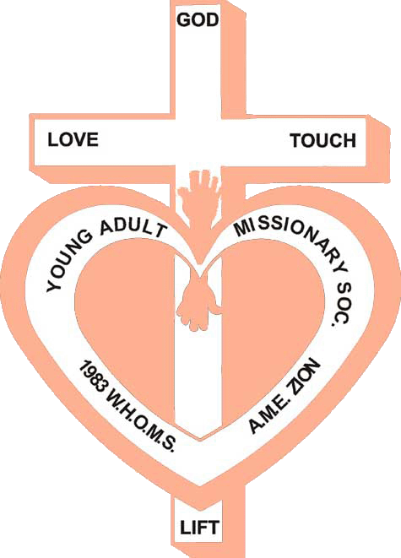

***November 2022***

***2019-2023 Quadrennial Theme:***

***“The Great Commission: #MissionsMatter”***

*Globally committed to Agape Love*

*Women’s Home and Overseas Missionary Society*

*The African Methodist Episcopal Zion Church*

*Dr. Joy L. Kennedy, PhD*

*Connectional Coordinator of the Y.A.M.S.*

*Mrs. Sandra Crowder*

*International President of the WH&OMS*