“Ways to Give Love”
From: synergyholistichealth.com

Offer your time: Volunteering just an hour of your week can make a monumental difference.

Complete a Favor: It is as simple as opening the door.

Give Your Support: Encouragement is powerful.

Be Their Feet: Help others complete tasks, adventure with them, and stand for others.

Be a Voice: Use your voice to provide moral instruction and to teach righteousness.

Offer Your Heart: Pray for others and be faithful in the power of prayer that you do not give up until you witness change.

Give Your Money: Be willing to give your money and possessions even those that you cherish.

Speak Kindly: Remind others that they are God’s child, they are valuable and loved.

Love: Because God has filled us with love, we can give more love.

Offer Your Attention: The world is filled with distractions, set those aside and just be present.

Young Adult Missionary Society
#MissionsMatter
Globally Committed to
Agape Love

Opening: Y.A.M.S. Motto

“With hearts and hands, We reach up to God for strength and direction. We reach out to love and touch others. We reach down to lift fallen humanity.”

Scripture Matthew 5: 14-16

Prayer

Introduction of Discussion Facilitator

Agape Love Table Talk Fellowship

Remarks

Closing Song: “I Need You to Survive”

Table Talk Topics:

- In what ways have you demonstrated God’s love towards your neighbor? (2019-2023 WH&OMS Study Guide, p. 80)
- What are some of the hindrances that keep you from experiencing or demonstrating God’s love towards yourself and/or others? (2019-2023 WH&OMS Study Guide, p. 80)
- Is Agape Love an essential ingredient in your life? (2019-2023 WH&OMS Study Guide, p. 83)
- Reflect: Are people drawn to you? (2019-2023 WH&OMS Study Guide, p. 83)
- Would your family or friends agree that your life is characterized by Agape Love? (2019-2023 WH&OMS Study Guide, p. 85)
- Share how love has lifted you at different times or circumstances in your life? (2019-2023 WH&OMS Study Guide, p. 93)
- How is Agape love essential to living out the Great Commission? (2019-2023 WH&OMS Study Guide, p. 93)
- How is Agape love essential to the life of a missionary locally and globally? (2019-2023 WH&OMS Study Guide, p. 93)

Young Adult Missionary Society
Historical Review

In 1983 at the 20th Quadrennial Convention in New Orleans, LA, the Young Adult Missionary Society was adopted as the sixth department of the Woman’s Home and Overseas Missionary Society. Dr. Adlise I. Porter, the 2nd Vice President, was appointed Coordinator of the department by the convention. Through her spiritual gifts, Dr. Porter developed the structure of the department, which included writing operational guidelines for the department’s Thematic Bible Studies, Social Concerns Projects, motto, colors, and theme song.
At the Quadrennial Convention in 1987 held in Boston, MA, the structural components were adopted for use on the general, district, and local levels of the Y.A.M.S., and subsequently ratified by the General Conference. Also, the title of “Coordinator” was given to the general, district, and local leaders of the Y.A.M.S. Prior to the 22nd Quadrennial Convention held in New Orleans, LA, the Y.A.M.S. Anniversary Day was called “Willa Mae Rice Day.” It was during this convention that a resolution was adopted to change “Willa Mae Rice Day” to “Founders Day” to honor Dr. Rice as founder and Dr. Porter as the Organizing Coordinator.
In 1991 at the 22nd Quadrennial Convention, Mrs. JoAnn B. Holmes, became the first elected General Coordinator and was re-elected in 1995 at the 23rd Quadrennial Convention in Detroit, MI. During the 23rd Quadrennial meeting, a resolution was adopted to change the ages of Y.A.M.S. from 27-40 to 22-40. To chart the course of the Y.A.M.S. into the 21st century, Mrs. Sandra B. Crowder was elected General Coordinator at the 24th Quadrennial Convention in Dallas, TX. At the 26th Quadrennial Convention in Orlando, FL, Mrs. Dawn L. Walker, became the 4th General Coordinator of the Y.A.M.S.
The current General Coordinator of the Y.A.M.S. is Dr. Joy L. Kennedy who was initially elected at the 28th Quadrennial Convention in Orlando, FL.

Y.A.M.S. Agape

Love Challenge

In-Reach Challenge: Create and implement an activity with Parent Body members to foster the development of intergenerational relationships within local churches, districts, and/or conference area.

Outreach Challenge: Plan and implement an outreach ministry that demonstrates Agape Love in action targeting young adults in your local community.

Agape Love in Action

YOUNG ADULT
MISSIONARY SOCIETY

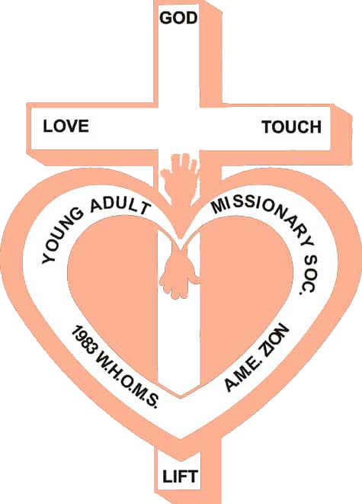

2019-2023 Quadrennial Theme:
“The Great Commission: #Missions Matter:
Globally committed to Social Justice,
Environmental Stewardship,
Transformative Service, and Agape Love”

Women’s Home and Overseas
Missionary Society
The African Methodist Episcopal Zion Church

Dr. Joy L. Kennedy, PhD
Connectional Coordinator of the Y.A.M.S.
Mrs. Sandra Crowder
International President of the WH&OMS

