



**Please send financial support to the District President for remittance to the**

**Executive Secretary, Mrs. Rosetta Dunham.**

**PO Box 26846, Charlotte, NC 28221**

**Women’s Home and Overseas Missionary Society**

**The African Methodist Episcopal Zion Church**

**BUREAU OF SUPPY PRAYER BREAKFAST**

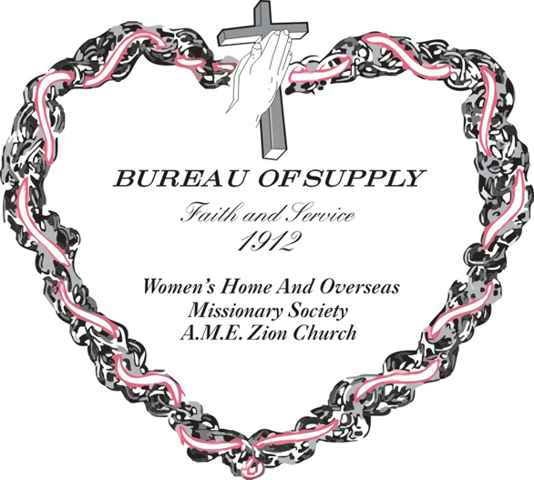

***Focus - The Great Commission: #MissionsMatter***

***Globally Committed to Transformative Service***

**Mrs. Jo-Ann O. Monroe, Connectional Secretary, Bureau of Supply**

**Mrs. Sandra B. Crowder, International President**

**Bureau of Supply Prayer Breakfast**

**(Enter Quietly and Prayerfully)**

**WORSHIP LEADER:**

**CALL TO WORSHIP**

I give you thanks, O Lord, with my whole heart; before the gods I sing your praise. I bow down toward your holy temple and give thanks to your name for your steadfast love and your faithfulness, for you have exalted above all things your name and your word. On the day I called, you answered me; my strength of soul you increased.

**INVOCATION**

Lord of the ages, creator of diverse cultures, nations, ethnicities and peoples, we are grateful to you. You Lord find lost sheep and you found us. The lost and broken might be over the oceans, or over the mountains, they might be across the deserts, or through the valleys, they might be in the countryside or deep in the heart of a city, but Lord you find those that cry out to you. We praise you O Lord, and ask for your guidance as you lead us to those that are broken and hurting in our world. Amen.

**OPENING HYMN:** *“O Master Let Me Walk With Thee”*

**SCRIPTURE**  Psalm 145:11-13

**RESPONSIVE READING**

***(Adapted from 2 Timothy 2:22)***

Leader: And the things you have heard me say

**People: In the presence of many witnesses**

Leader: Entrust to reliable people

**People: Who will also be qualified to teach others.**

**All: Lord, as we worship you today, empower us to pass on what you have done in us to others.**

**PRAYERS:**

**Prayer for transformative service to families**

**Prayer for transformative service for the community**

**Prayer for transformative service to the church**

**INTRODUCTION OF THE MEDITATION SPEAKER**

**SOLO or PRAISE DANCE**

**MEDITATION SPEAKER**

**BLESSING OF THE FOOD** *“Wesleyan Grace”*

***Breakfast Is Served***

**REMARKS/ANNOUNCEMENTS**

**MISSIONARY BENEDICTION**

*God be merciful unto us, and bless us, and cause His face to shine upon us, and give us peace. Amen.*

