***The Great Commission- #MissionsMatter***

***Globally Committed to***

***Agape Love***

***THE OFFERING APPEAL***

***Please make a recommitment offering in support of the Annie E. Walker Blackwell Observance. The funds will benefit home and overseas missionary projects.***

***Every man shall give as he is able according to the blessings of the Lord.***

**Remit Offerings to:**

**Your District President for remittance to:**

**Mrs. Rosetta Dunham**

**Executive Director**

**P.O. Box 26846**

**Charlotte, North Carolina 22821-6846**

**Program Prepared by:**

**Ms. Renee Felton Pullen**

**Second Vice-President**

**Mrs. Sandra B. Crowder**

**International President**

***“Keep Everlasting at It”***

***With Agape Love!***

***Annie E. Walker Blackwell***

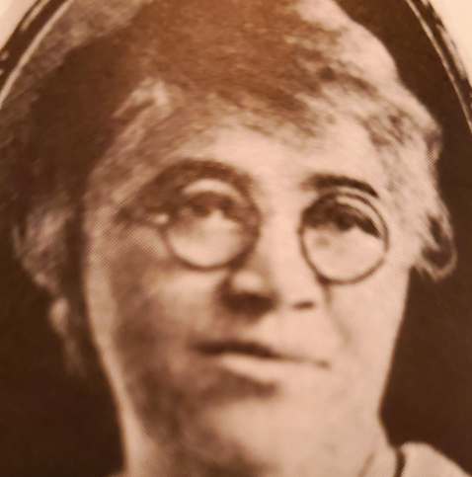

**A Visionary Missionary**

**December 2022**

**(Suggestion: Use at a local missionary meeting**

**or district mass meeting.)**

**“The Great Commission – #MissionsMatter:**

**Emphasis: Agape Love**

***ANNIE E. WALKER BLACKWELL***

***Agape love Discussion***

**the invocation**

**The Scripture I john 4;8-10**

**The praise medley** [**https://www.youtube.com/results?search_query=agape+love+song+shadonna**](https://www.youtube.com/results?search_query=agape+love+song+shadonna)

* **Open Discussion**
  + **Agape love**
    - **what is agape love to you?**
    - **How are you showing agape love as missionaries?**
    - **give examples of agape love in your outreach**
    - **how are you showing agape love to the departments of whoms**

**THE ANNIE E. WALKER BLACKWELL LOVE OFFERING**

**the Closing hymn “Lift Him Up”**

**THE MISSIONARY BENEDICTION**



***Remember the Leader***

***ANNIE E. WALKER BLACKWELL***

**August 21, 1862 - December 7, 1922**

Corresponding Secretary of

Woman’s Home and Foreign Missionary Society, 1904-1922

Annie E. Walker Blackwell was born on August 21, 1862 in Chester South Carolina. She was educated in Scotia Seminary in Concord, North Carolina. On December 7, 1887, Annie married Rev. George Lincoln Blackwell, who later became a Bishop of the A.M.E. Zion Church, elected in 1908. During that period, Bishops did not appoint “Supervisors,” thus, she assumed the role as a “Vice President.” It was Mrs. Blackwell’s recommendation that laid the groundwork for the change in title from Vice-President to Supervisor.

At the General Conference of 1904, Mrs. Annie E. W. Blackwell was elected Corresponding Secretary of the W.H. &F.M. Society, a position she held for 18 years. Annie E. W. Blackwell was a visionary. She envisioned the economic potential of the society’s life membership program provided for in the constitution. As the result of her perseverance, the first persons were enrolled as life members at the Missionary Convention in 1906.

Annie Blackwell saw the need for additional training in Africa for young people. She envisioned a girl’s school that might equip them for greater service.

Annie E. W. Blackwell died on her thirty-fifth wedding anniversary, December 7, 1922, and was buried in Eden Cemetery, Philadelphia, Pennsylvania.

Her motto was “Keep everlastingly at it”.